1. Difference b/w Angular 2, 4,5

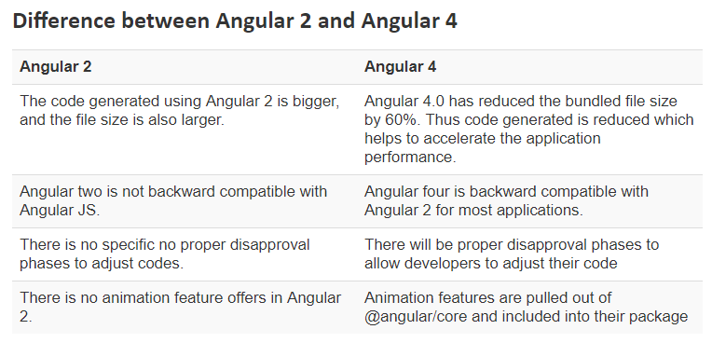

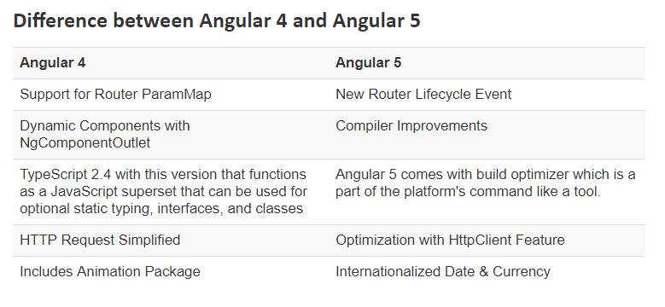

1. Types of Directives

There are three kinds of directives in Angular:

1. Components—directives with a template.
2. Structural directives—change the DOM layout by adding and removing DOM elements. *ngIf, *ngFor, [ngSwitch], ngSwitchCase
3. Attribute directives—change the appearance or behavior of an element, component, or another directive. ngClass and ngStyle. Refer: https://angular-2-training-book.rangle.io/handout/directives/ng_class_directive.html
4. *ngIf and expanded form

<div *[ngIf](https://angular.io/api/common/NgIf)="hero" class="name">{{hero.name}}</div>

Expanded Form:

<ng-template [[ngIf](https://angular.io/api/common/NgIf)]="hero"> <div class="name">{{hero.name}}</div> </ng-template>

1. *ngFor and expanded form

<div *[ngFor](https://angular.io/api/common/NgForOf)="let hero of heroes; let i=index; let [odd](https://angular.io/api/common/NgForOfContext#odd)=[odd](https://angular.io/api/common/NgForOfContext#odd); trackBy: [trackById](https://angular.io/api/core/IterableChangeRecord#trackById)" [class.odd]="[odd](https://angular.io/api/common/NgForOfContext#odd)"> ({{i}}) {{hero.name}} </div>

Expanded Form:

<ng-template [ngFor](https://angular.io/api/common/NgForOf) let-hero [[ngForOf](https://angular.io/api/common/NgForOf)]="heroes" let-i="index" let-odd="[odd](https://angular.io/api/common/NgForOfContext#odd)" [[ngForTrackBy](https://angular.io/api/common/NgForOf" \l "ngForTrackBy)]="[trackById](https://angular.io/api/core/IterableChangeRecord" \l "trackById)"> <div [class.odd]="[odd](https://angular.io/api/common/NgForOfContext#odd)">({{i}}) {{hero.name}}</div> </ng-template>

Read <https://angular.io/guide/structural-directives>

1. How to write custom directives. Refer: -> <https://codecraft.tv/courses/angular/custom-directives/overview/>
2. What re Pipes in Angular 2:
   1. A pipe takes in data as input and transforms it to a desired output.
   2. 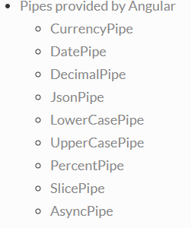
   3. Code for custom pipe:
   4. 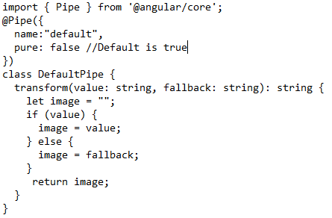
3. Pure and Impure Pipes: <https://blog.angularindepth.com/the-essential-difference-between-pure-and-impure-pipes-and-why-that-matters-999818aa068>  
   <https://www.code-sample.com/2017/05/angular-2-pure-and-impure-pipes.html>
4. Difference b/w Promise and Observable : <https://fullstack-developer.academy/angular-promise-vs-observable/>  
   <https://www.oodlestechnologies.com/blogs/What-Is-The-Difference-Between-Observable-And-Promises>  
   <https://medium.com/@mpodlasin/promises-vs-observables-4c123c51fe13>  
   <https://angular-2-training-book.rangle.io/handout/observables/observables_vs_promises.html>
5. Pass additional Header Info into angular HTTP request.  
   <https://medium.com/@premchandkumar/update-angular-4-http-request-with-querry-params-7616658de045>  
   <https://www.concretepage.com/angular-2/angular-2-http-get-parameters-headers-urlsearchparams-requestoptions-example>
6. Angular 2 and JWT Authentication:  
   <https://medium.com/beautiful-angular/angular-2-and-jwt-authentication-d30c21a2f24f>
7. Angular 2 Lifecycle  
   <https://angular-2-training-book.rangle.io/handout/advanced-components/component_lifecycle.html>  
   https://codecraft.tv/courses/angular/components/lifecycle-hooks/
8. Difference b/w constructor and ngOnInit - <https://blog.angularindepth.com/the-essential-difference-between-constructor-and-ngoninit-in-angular-c9930c209a42>
9. Difference b/w Directives and Components : <https://www.dev6.com/Angular2-Components-and-Directives>  
   <https://blog.angular-university.io/angular-components-and-directives-for-beginners>
10. What is Shadow DOM: <https://glazkov.com/2011/01/14/what-the-heck-is-shadow-dom>  
    <https://www.html5rocks.com/en/tutorials/webcomponents/shadowdom/>
11. ngOnchanges - <https://www.concretepage.com/angular-2/angular-2-4-onchanges-simplechanges-example>
12. ngDoCheck - <https://blog.angularindepth.com/if-you-think-ngdocheck-means-your-component-is-being-checked-read-this-article-36ce63a3f3e5>
13. Change Detection Startegy : <https://medium.com/@bencabanes/angular-change-detection-strategy-an-introduction-819aaa7204e7>  
    <https://netbasal.com/a-comprehensive-guide-to-angular-onpush-change-detection-strategy-5bac493074a4>  
    <https://alligator.io/angular/change-detection-strategy>  
    <https://angular-2-training-book.rangle.io/handout/change-detection/change_detection_strategy_onpush.html>
14. AOT Compilation: <https://medium.com/spektrakel-blog/angular2-going-production-ready-with-ahead-of-time-compilation-aot-developer-experiences-aebaa0228909>  
    <https://angular-2-training-book.rangle.io/handout/aot>  
    <https://www.dotnetcurry.com/angularjs/1450/angular-ahead-of-time-aot>
15. Lazy Loading : <https://angularfirebase.com/lessons/how-to-lazy-load-components-in-angular-4-in-three-steps>  
    <https://angular-2-training-book.rangle.io/handout/modules/lazy-loading-module.html>  
    <https://medium.com/@kouipheng.lee/lazy-loading-with-angular-4-29c23792b7f4>
16. Route Guards: <https://codeburst.io/using-angular-route-guard-for-securing-routes-eabf5b86b4d1>  
    <https://dzone.com/articles/implementing-guard-in-angular-5-app>  
    <https://scotch.io/tutorials/protecting-angular-v2-routes-with-canactivatecanactivatechild-guards>  
    <https://www.tektutorialshub.com/angular-route-guards>
17. Component Inheritance in Angular 2 -> <https://medium.com/@amcdnl/inheritance-in-angular2-components-206a167fc259>  
    <https://coryrylan.com/blog/angular-component-inheritance-and-template-swapping>  
    <https://angular-2-training-book.rangle.io/handout/features/inheritance.html>  
    <https://blogs.msdn.microsoft.com/premier_developer/2018/06/17/angular-how-to-simplify-components-with-typescript-inheritance>  
    <https://stackoverflow.com/questions/35542915/in-angular2-use-inheritance-or-inject-dependency>
18. Service Inheritance : <https://medium.com/.../angular2-decorators-and-class-inheritance-905921dbd1b7>  
    <https://angular.io/guide/hierarchical-dependency-injection>  
    <https://stackoverflow.com/questions/41817759/how-to-inherit-injected-service-from-superclass-into-subclassed-component-in-ang?rq=1>